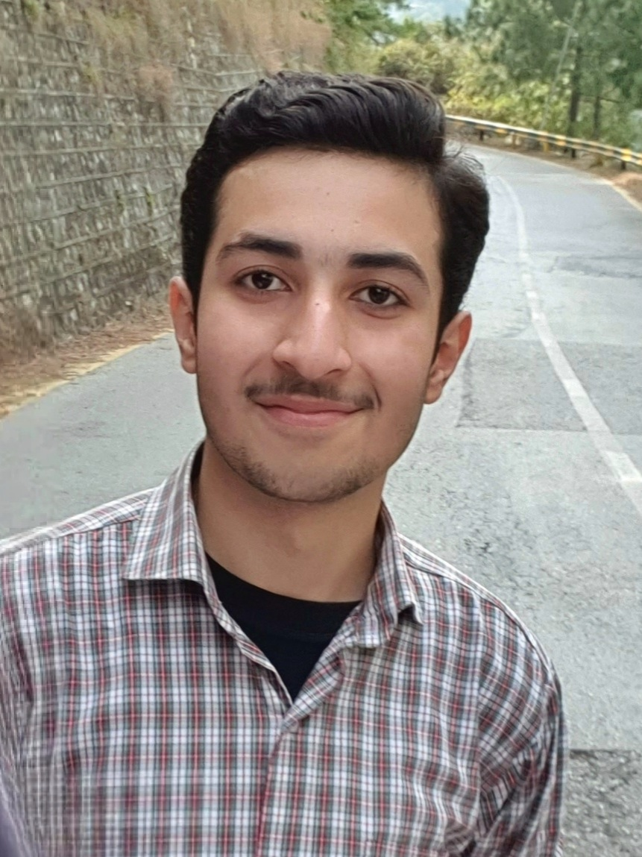**Hassan Abbas**

i210507@nu.edu.pk  +923234433618  Rawalpindi, Pakistan

**EDUCATION**

**FAST NU ISLAMABAD Completed 4th Sem Bachelors in Computer Science**

* Member of MLSA, FCS, FYLS, FBS
* Participant of Hackathons, Coding competitions and Seminars/Webinars.
* TA in Programming Fundamentals, OOP and Lab Demonstrator of OOP

**SKILLS & INTERESTS**

* **Skills***:*
* **Web Development***:*
* Proficient in front-end web development languages such as **HTML**, **CSS** and **JavaScript**
* Adept at back-end language **C#**
* **Databases:**
* Practiced at building and working on **Database Systems** and **SQL** on Microsoft SQL Workbench
* Able to integrate a front-end with a Database System
* **Desktop Applications:**
* Skilled at **C++** in Data Structures, OOP, and Operating system concepts.
* Able to create Neural Networks from scratch
* Familiar with **Python** up to a novice degree.
* Worked with **Bash** to write scripts in Linux environment.
* **Mobile Applications:**
* Basic knowledge of **Java**, **Flutter** and **JavaScript** to build very simple mobile applications.
* **Game Development:**
* Novice at Unity development.
* Expert at building **2D Interactive games** with **GLUT**, **SMFL** in **C++** and **Assembly Language**.
* **Interests***:*
* Learning Mobile Application development
* Participating in hackathons and coding challenges
* Learning Web Development by self
* Making simple video games
* Mentoring and teaching others about web development and programming
* Gaming and building gaming websites and applications
* Music production and audio engineering, and developing audio-focused web applications.